


Student Association with Frontend
Project Report

Submitted To
Mrs. Priyanka E18375

In partial fulfilment for the award of the degree of


Master of Computer Application

2025-2027
Submitted By:
Name : Saurav Bhuria
UID: 25MCA20133
Sec: 25MCA-6(B)

Declaration

I hereby declare that the project report entitled “Student Association Management System with Frontend Validation and Testing” submitted in partial fulfilment of the requirements for the award of the degree of Master of Computer Applications is my original work. This project has been carried out by me under the guidance of Mrs. Priyanka.

I confirm that this work has not been submitted previously to any other university or institution for the award of any degree or diploma. The project focuses on developing a frontend-based student association system that enables user registration, login authentication, password validation, CAPTCHA verification, and dynamic date of birth selection using HTML, CSS, and JavaScript.

All the sources of information and references used in this project have been properly acknowledged. I have made every effort to ensure the accuracy and authenticity of the content presented in this report. I take full responsibility for any errors or omissions, if found.

This project has enhanced my practical knowledge of frontend development, user interface design, validation techniques, and software testing implementation.

Acknowledgement

I would like to express my sincere gratitude to everyone who contributed to the successful completion of my project titled “Student Association Management System with Frontend Validation and Testing.” This project has been a valuable learning experience, and its completion would not have been possible without the guidance and support of several individuals.

First and foremost, I am highly thankful to my respected teacher Mrs. Priyanka, Department of MCA, for her continuous guidance, valuable suggestions, and encouragement throughout the development of this project. Her expertise and support helped me understand the practical aspects of frontend development and software testing.

I would also like to thank the Department of MCA for providing the necessary resources and environment to carry out this project successfully. My heartfelt thanks go to my friends and classmates for their support, motivation, and helpful discussions during the project work.

I am deeply grateful to my family for their constant encouragement and moral support, which kept me motivated throughout the project.

Finally, I would like to thank all those who directly or indirectly contributed to the successful completion of this project.

Name: Saurav Bhuria
Submission Date: 15/Apr/2026

Table of Content
S.No | Topic | Page No.
1. | Introduction
2. | Software & Hardware Requirement
3. | Interface Test Case
4. | Frontend Test Case
5. | Logic Test Case
6. | Functional Test Case
7. | Regression Test Case
8. | Test Report
9. | Decision Tables
10. | Screenshots of Output
11. | Conclusion
12. | GitHub Link

- 1. Introduction:
The Student Association Management System is a frontend-based web application developed using HTML, CSS, and JavaScript. This system is designed to provide a simple, interactive, and user-friendly platform for students to register and log in securely.
The application includes essential features such as user registration (signup), login authentication, password validation, CAPTCHA verification, and dynamic date of birth selection. These features ensure that only valid users can access the system while maintaining data accuracy and basic security.
The focus of this project is not only development but also software testing, particularly frontend testing. Various testing techniques such as GUI testing, functional testing, logic testing, and regression testing are applied to ensure that the application behaves correctly under different conditions.
Special attention has been given to validation mechanisms, including password matching, CAPTCHA correctness, and proper handling of user inputs. The system also uses browser-based storage (Local Storage) to simulate data handling without a backend, making it a purely client-side application.
This project helps in understanding the real-world implementation of frontend technologies along with testing methodologies. It demonstrates how a user interface can be designed effectively while ensuring reliability, usability, and correctness through proper testing practices.

- 2. Software & Hardware Requirement
- Software:
Web Browser (Google Chrome / Edge)
Visual Studio Code
HTML, CSS, JavaScript

- Hardware:
Minimum 4GB RAM
Intel i3 or above
Windows OS

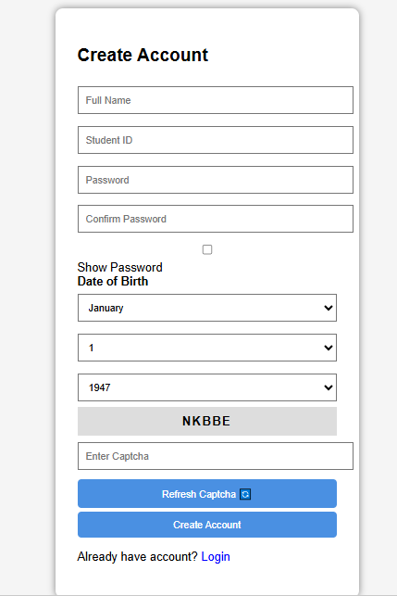
- 3. Interface Test Case:
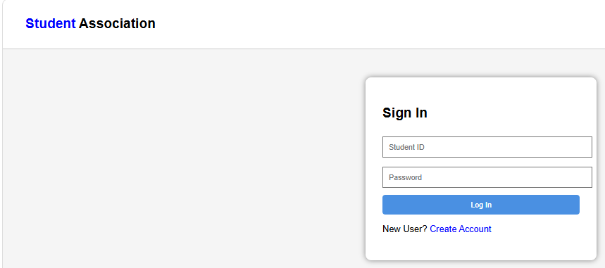

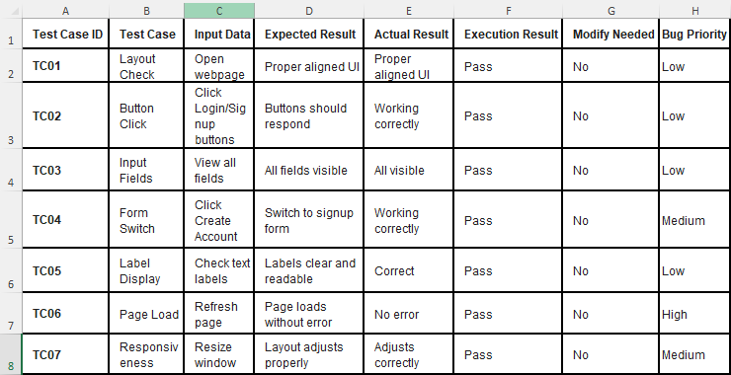

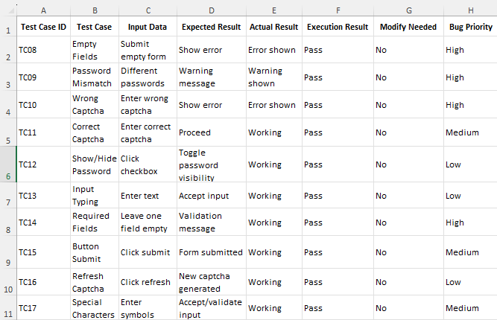
- 4. Frontend Test Case:

- 5. Logic Test Case:
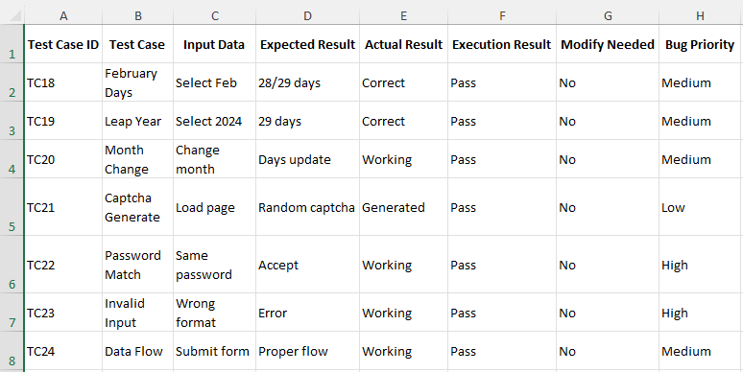

- 6. Functional Test Case:
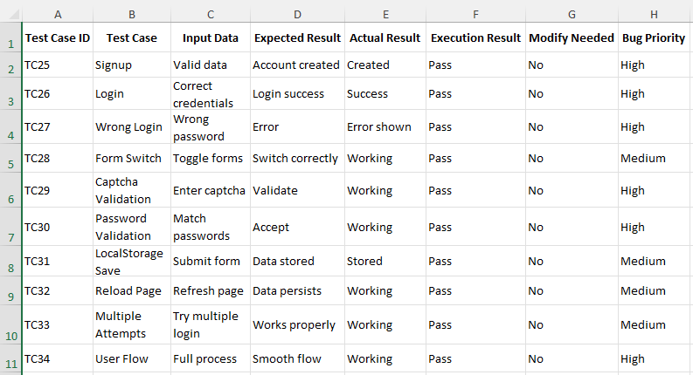

- 7. Regression Test Case:
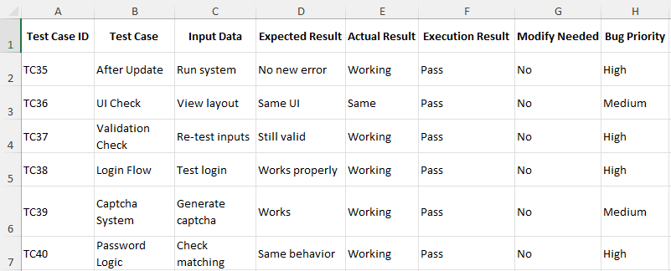

8. Test Report
- Execution Summary:
- Total Test Cases Executed: 40
- Test Cases Passed: 38
- Test Cases Failed: 2
- Pass Percentage: 95%

- Defect Log (Failed Tests):
1. BUG-001: Data stored in Local Storage is not secure
Description: User password is stored in browser Local Storage in plain text format.
Impact: Security risk (anyone can view password via inspect tool).
Recommendation: Use encryption or backend authentication instead of storing sensitive data on client-side.

2. BUG-002: Captcha is case-sensitive without instruction
Description: Captcha validation fails if user enters correct characters but in lowercase/uppercase mismatch.
Impact: Poor user experience.
Recommendation: Make captcha case-insensitive or display instruction clearly.

9. Decision Table
Decision Table: User Registration Validation
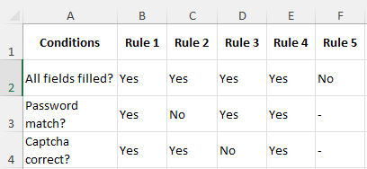

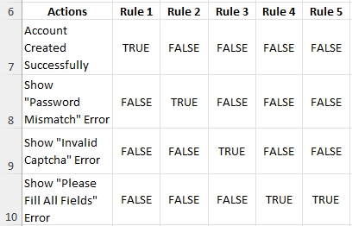

- 10. Screenshot of Output:
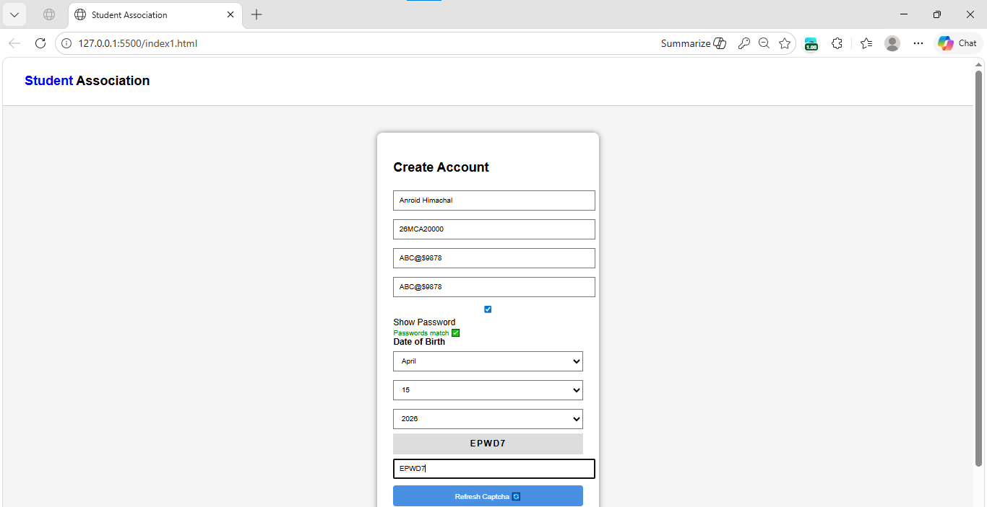

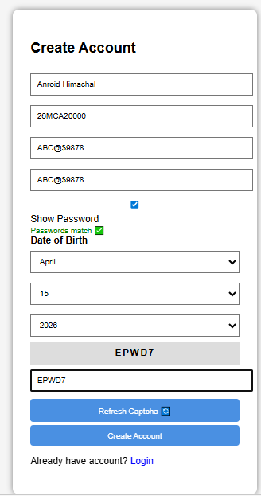

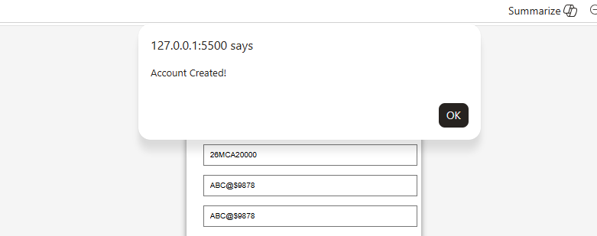

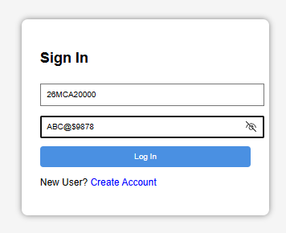

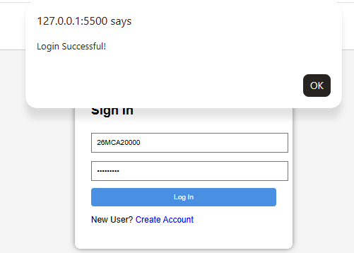

- 11. Conclusion:
- The Student Association Management System is successfully developed using HTML, CSS, and JavaScript.
- The system provides functionalities like signup, login, password validation, and CAPTCHA verification.
- Frontend validation ensures correct user input and improves user experience.
- Various testing techniques such as GUI, functional, logic, and regression testing were applied.
- Most of the test cases passed successfully, indicating a reliable system.

- 12.GitHub Link:

